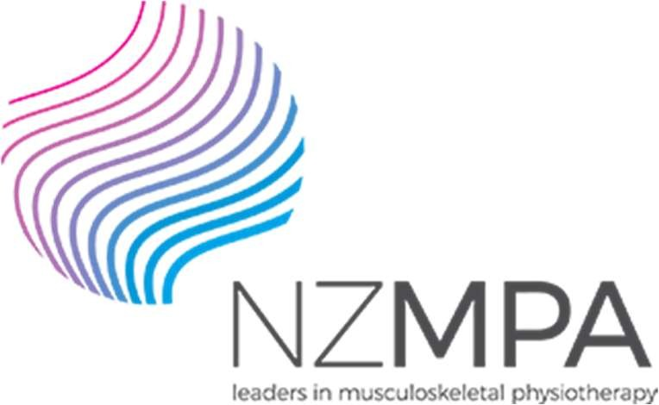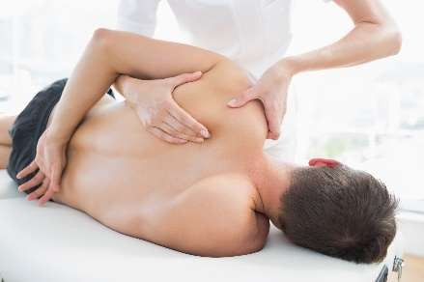

COMT 2020
Book online viz PNZ Events Directory
https://pnz.org.nz/pnz-events-directory The dates stated and schedule are provisional.
A minimum of 20 participants for each venue must be confirmed for course to take place, unless approved by NZMPA.

Day One | Day Two | Course | Lead Tutor | Location
4-Jul | 5-Jul | The Shoulder | Angela Cadogan | Auckland
5-Sep | n/a | HVT Review & Update | Duncan Reid | Auckland
17 Oct  7-Nov | 18 Oct  8-Nov | Elbow, Wrist & Hand  Thoracic plus Review | Jill Caldwell  Duncan Reid | Auckland  Auckland
12-Sep 31-Oct  21-Nov | 13-Sep 1-Nov  22-Nov | The Shoulder Elbow, Wrist & Hand  Thoracic plus Review | Angela Cadogan Jill Caldwell  Michael Monaghan | Wellington Wellington  Wellington
25-Jul  22-Aug | 26-Jul  23-Aug | Low Back Pain Part 1 CANCELLED  Low Back Pain Part 2 CANCELLED | Steve White  Steve White | Christchurch  Christchurch
19-Sep | 20-Sep | Hip & Knee  CANCELLED | Steve White Bronwyn Harman | Christchurch
17-Oct | 18-Oct | Review plus Foot & Ankle  CANCELLED | Richard Ellis Michael Monaghan | Christchurch
- Following Covid-19, NZMPA's courses are contingent on minimum numbers to make the courses viable. Participants are strongly encouraged to commit early to the course, so NZMPA can confirm course go- ahead early and at least two weeks before start date.
NZMPA reserves the right to cancel a course should minimum numbers not be achieved.
- Courses are subject to confirmation of venues, tutor flights and course numbers and changes to the Covid- 19 alert levels.
- Limited class participants: Minimum 20, up to a maximum 30 participants.
- Should a participant have to cancel due to Covid-19 or other reasons, NZMPA will look to offer a credit of the same value/confirmation placement towards your next course.
- Course participants are asked not to attend if they are feeling unwell or having symptoms of Covid-19 or been exposed to someone quarantining within 48 hours of course commencement.
- We refer you to the Covid-19.govt.nz website here for further details for gatherings under Alert Level 2 and Alert Level 1 (update due 8th June 2020)

NZMPA | 09 476 5353 | 0800 646 000
w ww.nzmpa.org.nz | admin@nzmpa.org.nz
PO Box 35602 | Browns Bay | Auckland 0753

